**Assignment -2**

|  |  |
| --- | --- |
| Assignment Date | 27 September 2022 |
| Student Name | Ms. KANDGADDALA VARSHITHA |
| Student Roll Number | 111519106063 |
| Maximum Marks | 2 Marks |

**QUESTION 1:**

**BUILD A PYTHON CODE , ASSUM EYOU GET A TEMPERATURE AND HUMIDITY VALUES GENERATED WITH RANDOM FUNCTION TO A VARIABLE AND WRITE A CONDITION TO CONTINUOUSLY DETECT ALARM IN CASE OF HIGH TEMPERATURE.**

PYTHON CODE: 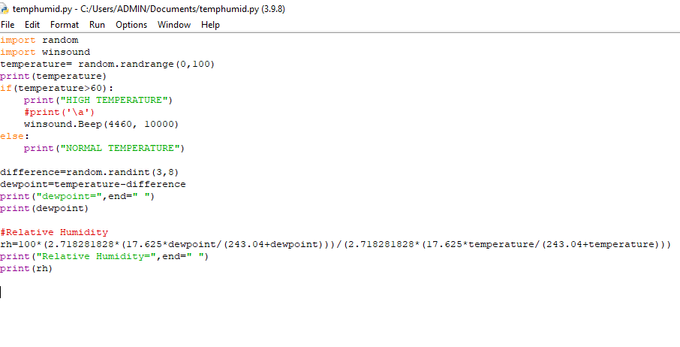

OUTPUT:

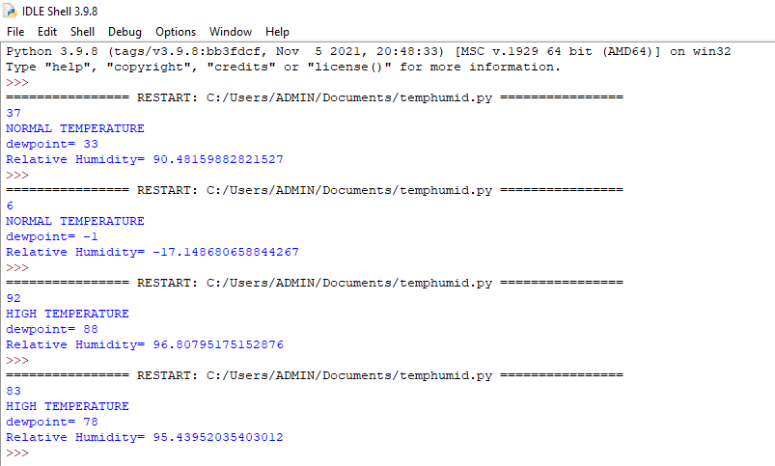

**IN ANOTHER WAY:**

CODE:

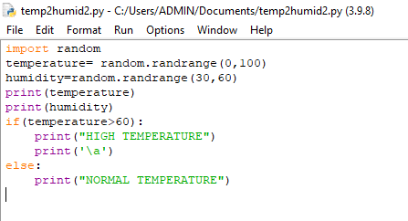

OUTPUT:

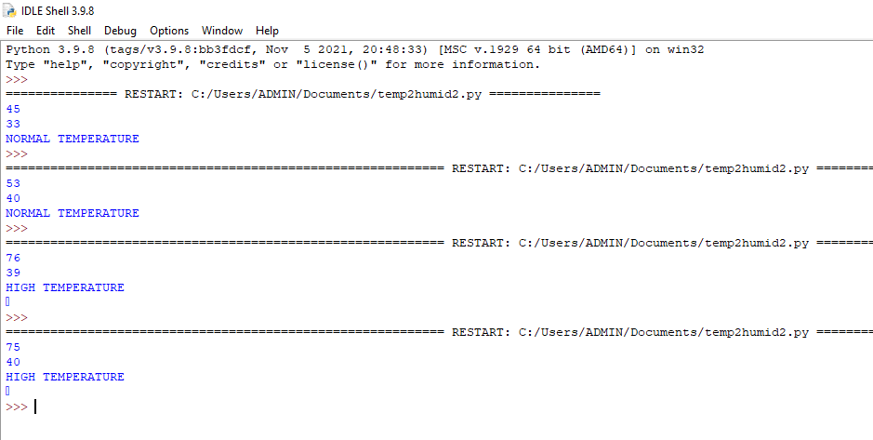

**LINK FOR THE VIDEO**

**https://drive.google.com/file/d/1elVVG7zVG5dWDWgX9ePDr-9G1h0d7CQK/view?usp=sharing**